

Name : Yashini Devi Seagaran

Login ID : R03412925@oasis-portal.com

Course title : Executive Diploma in Business and Hospitality Management

Subject Code : BHM04 Tourism and Hospitality

Submitted date: **11/ September / 2017**

**Table of Contents**

|  |  |  |
| --- | --- | --- |
| **No** | **Details** | **Page** |
| 1 | Executive Summary | 2 |
| 2 | Introduction | 3 |
| 3 | Assignment Question |  |
|  | Part 1 | 4 – 8 |
|  | Part 2 | 9 – 14 |
|  | Part 3 | 15 – 19 |
|  | Part 4 | 20 – 22 |
| 4 | Conclusion | 23 |
| 5 | References | 24 |
|  | Appendix | 25 |

**Executive Summary**

**For Question 1 :** I have learned about what tourism and hospitality is, that is by defining and describing the tourism and hospitality, with examples such as the main sector accommodation, food and beverage and transportation. I also learn the different type of sector in the hospitality industry.

**For Question 2 :** I have learned about the types of tourism categories, describing about the types of tourism categories with example such as leisure tourism, culture tourism, business tourism, education tourism, family tourism and etc. I also got to know about the definition of tourism.

**For Question 3:** During this assignment I have learned about lodging accommodation and types of hotel accommodation and also I have known about the concept of lodging and accommodation in hospitality sector.

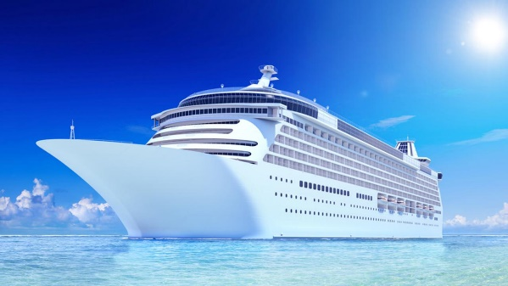**For Question 4:** I have learned about the importance of entertainment in this industry with examples such as cruises: people like to spend their days on luxury ships which sail across the blue oceans under the clear sky. There have many types of cruises such as carnival cruise, silver seas cruises, royal Caribbean and etc.

**Introduction**

Tourism and hospitality is one of the fastest growing sectors of the economy of our world today. There are multiple billion dollars companies are here now. Many peoples definition of tourism and hospitality extends only to restaurants and hotels. In reality, it goes for beyond this and includes any organization that provides food, shelter, and other services to people away from home. When viewed in this, the tourism and hospitality industry can be quite large.

Tourisms is a short-term move while people go to destinations outside of where they usually live and work, and their activities during their stay at the destinations. Tourism categorized many such as leisure tourism, culture tourisms, religious tourisms, family tourisms, health tourisms, sports tourisms, educational tourisms, business tourisms, and alternative forms tourisms.

Hospitality can be defined to make others feel comfort, no matter what the situation is. It includes respects, sharing, kindness, and tolerance. Hospitality industry includes lodging, travel and tourism, recreation, amusements, attractions, resorts, restaurants, and food beverage service.

**Assignment Questions**

**Q1: Define the tourism and hospitality. Explain your understanding about hospitality industry.**

For the first question in my opinion, tourisms defined as a unique phenomenon for modern time that depends on the people’s need for change and relaxation. The desire to recognize the beauty of nature and art and the belief that nature gives happiness to humans, and that helps countries and communities approach thanks to developments in commerce and industry and communication and transport means to be very good. Tourism also is collection of activities, services and industries which deliver a travel experience comprising transportation, accommodation, eating and drinking, entertainment, business, and other hospitality services provided for individuals or groups travelling away from home.

Hospitality is the relationship between guests and host, or the act or practice of being hospitable. Specifically, this includes the reception and entertainment of guests, visitors, or strangers, resorts, membership clubs, conventions, attractions, special events, and other services for travelers and tourists. Hospitality ‘can also mean generously providing care and kindness to whoever is in need.

The hospitality fields, by definition is a service industry. Its task is to create shareholder wealth by servicing and satisfying guests. Industry segments, includes among others: hotels, restaurants, private clubs, managed food service, event planning, tourisms related business, and travel providers more often than not, the product purchased is either intangible or the received quality of the product purchased is impacted by the service method in which it was received. Noted that in hospitality, the service provider is “part of the product itself “for the guest to be satisfied they not only most believe that they have received a valuable service for their dollar, but also feel valued and respected by the workers providing the service.

Hospitality industry includes the companies or organizations which provide food and drink and accommodation to people who are away from home. The hospitality industry meets the needs of people with kindness and goodwill while they are away from their homes. The hospitality industry has four service sectors:

* Lodging-Accommodation
* Food and Beverage
* Travel and Tourism
* Recreation

The hospitality industry is about service. The industry provides service to people when they are away from their home sometimes even when they are home. For example home delivery food would be part of the hospitality industry as would a masseuse that does home visits or a cook that does at home catering.

The hospitality industry is about diversity. There are small, large, privately owned, and publicly owned business. There are people of every socioeconomic class, cultural background, race, age, and religion involved with hospitality, its providing and receiving the services. The hospitality industry reaches every corner of the globe, while providing jobs, entertainment, food, transportations, and a place sleep.

The hospitality industry is about entrepreneurs. This field is full of business that serve people and are owned by a single person or family. This means not only are there many hospitality jobs working for someone else. There is a lot of hospitality opportunity to work for yourself.

* **Lodging-Accommodation**

Lodging, also known as accommodation, is a place to sleep for one or more nights. A business in the lodging industry provides a place for people to sleep overnight. People who travel and stay away from house for more than a day need lodging for sleep, rest, food, safety, shelter from cold temperatures or rain, storage of luggage and access to common household functions. It can be one of many sleeping places such as a fancy hotel, a youth hostel, an elder hostel, a campground, or highway side motel, suites, and resorts.

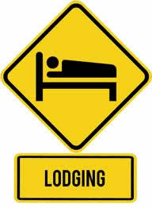

* **Food and Beverage**

The food and beverage industry, also known as the foodservice industry. This is another important thing in these five sectors of the hospitality industry. This is another hotel industry sector. The food and beverage sector ruled the industry’s highest. And, for good reason. It can consist of something as simple as a bistro along the way to a fancy restaurant and every catering establishment in between. As expected, the food and beverage industry continues to be a subcategory of the niche.

Food and Beverage Department (F&B) is responsible for maintaining high quality of food and service, food costing, managing restaurants, bars, etc. Food and Beverage Service is the service of Food made in the Kitchen and Drinks prepared in the Bar to the Customers (Guest) at the Food & Beverage premises, which can be: Restaurants, Bars, Hotels, Airlines, Cruise Ships, Trains, Companies, Schools, Colleges, Hospitals, Prisons, Takeaway, etc.





* **Travel And Tourisms**

The travel industry is in the business of moving people from place to place while the tourism industry provides those people with services that promote travel and vacations. Busses, planes, cabs, boats, and passenger trains are all part of the travel industry while travel agencies, tour operators, cruise companies, convention planners, and visitors bureaus are all part of the tourism industry. Tourism can be domestic or international, and international tourism has both incoming and outgoing implications on a country's balance of payments. Today, tourism is a major source of income for many countries, and affects the economy of both the source and host countries, in some cases being of vital importance.

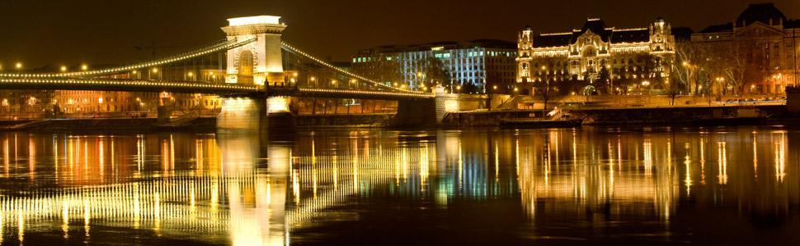



* **Recreation**

Recreation is any activity that people do for rest, relaxation, and enjoyment. The goal of recreation is to refresh a person’s body and mind. Any business that provides an activity for rest, relaxation, and enjoyment in order to refresh a person’s body and mind is in the recreation business. Recreation businesses are incredibly diverse because people have varying ideas on what activities they participate in for rest, relaxation and enjoyment. There are four general types of recreation businesses: entertainment, attractions, spectator sports, and participatory sports, such as: Singapore Marina Bay, Universal Studio, Sentosa Beach, Marina Bay Sands, ETC.

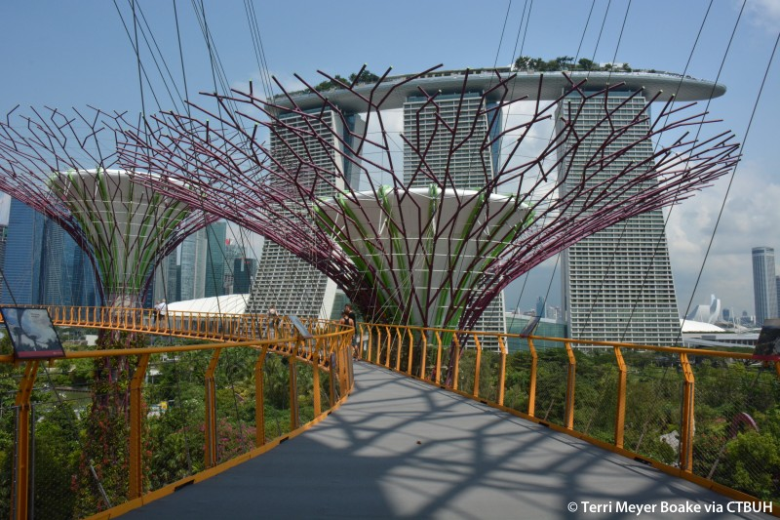

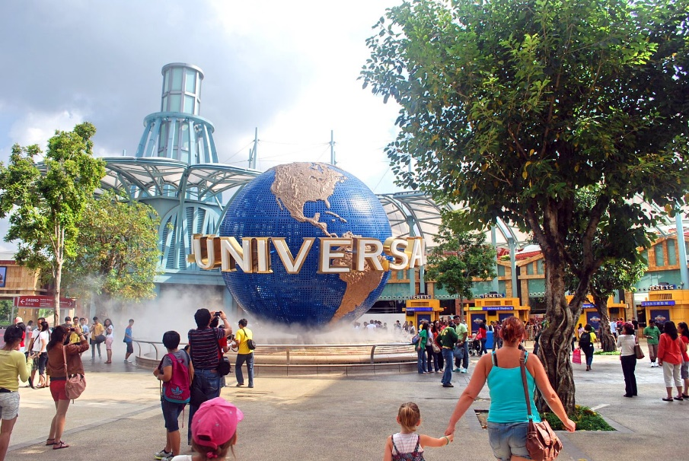

**Q2: Brief on different type of Tourism categories. Define Tourism.**

How will you define a tourisms?Tourisms can be defined, who makes a tour away from home for leisure, business or other purposes for more than one day but less than a year. Based on their various needs and reasons for traveling, tourists are classified in the following categories:

* Mass Tourism
* The organized movement of large groups of people to specialized tourist locations.
* A consequence of the increase of people traveling for pleasure; Developed to cater to huge numbers of tourists.
* Examples: whole resort towns, theme parks, tourism business districts, cruises, packaged vacations, all-inclusive resorts, etc.
* Alternative Tourism
* Individually planned activities to gain and experience first-hand knowledge about local cultures and environments.
* Focus on secluded areas, occur during non-peak traveling times, can include arranging own flights and accommodations.
* Example: a self-planned biking trip through Vermont, while camping or arranging accommodations "as you go."

These "types of tourism" categories are a useful way to start looking at where tourists go, why they go there, and what they do while on vacation. However, it is important to note that these categories are not always as clear cut as they suggest, as travelers will engage in variety of activities while on vacation, many of which overlap into more than one category.

* Leisure Tourism

Leisure travel is travel in which the primary motivation is to take a vacation from everyday life. Leisure travel is often characterized by staying in nice hotels or resorts, relaxing on beaches or in a room, or going on guided tours and experiencing local tourist attractions.

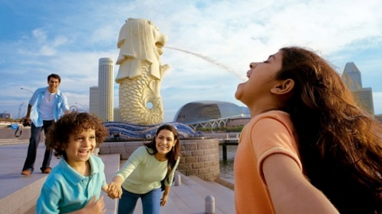

* Cultural Tourism

Cultural tourist want to experience different cultures, such as San rock art, or cultural related festivals such as the National Art Festival in Grahams-town, or the International Jazz Festival in Cape Town. They would also want to experience the World Heritage Sites in the country. Culture tourism is the subset of tourism concerned with a traveler's engagement with a country or region's culture, specifically the lifestyle of the people in those geographical areas, the history of those people, their art, architecture, religion, dress, jewelry, dance, music, and other elements that helped shape their way of life.

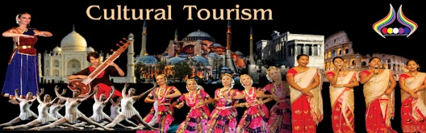

* Religious Tourism

Religious tourism, which is also commonly referred to as tourism of faith, is a type of tourism, in which individuals move individually or collectively for the purpose of pilgrimage, missionary, or leisure. For example. The largest religious form of the world religions takes place at the annual Hajj pilgrimage in Mecca, Saudi Arabia.

Religious tourism, has a great future in India. India is rich in ancient temples and religious festivals. Religion from India, whether Hindu, Sikhism, Jainism or Buddhism, has a vibrant spiritual culture and philosophy. Together, they demonstrated a viable alternate way of life as opposed to materialism and confrontation spread across the West.

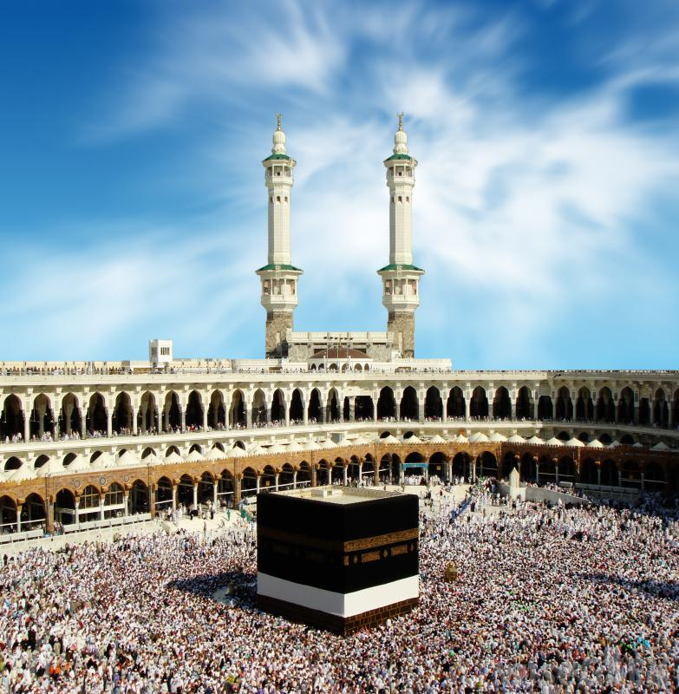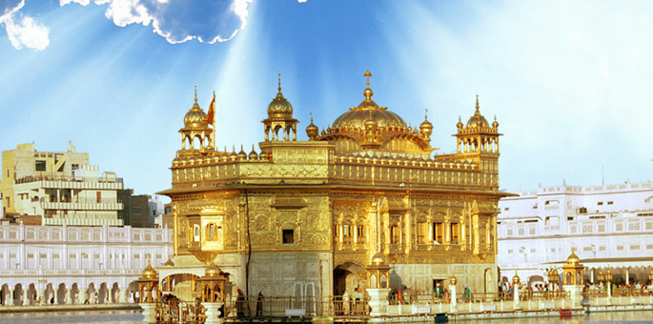

* Adventure Tourism

Adventure tourism is a type of niche tourism involving exploration or travel to remote areas, where the traveler should expect the unexpected. Adventure tourism is rapidly growing in popularity as tourists seek unusual holidays, different from the typical beach vacation. It also involves travelling into remote inaccessible and possibly hostile areas. It may include the performance of acts that require significant effort and effort and grid and may also involve some degree of risk.

* Education Tourism

Educational tourism is an increasingly popular new trend in the global tourism industry. According to scholars, the concept of a wide range of educational tourism, it has been changing the concept of tourism itself. Educational tourism is those people, including education and learning is their main purpose of this trip to carry out tourism activities. In other words, the main purpose of travel is to obtain knowledge and experience on certain topics, rather than travel itself. Historically, we know that we have defined the initial educational travel tour starting today, excursions and discovery in the form of cruises.

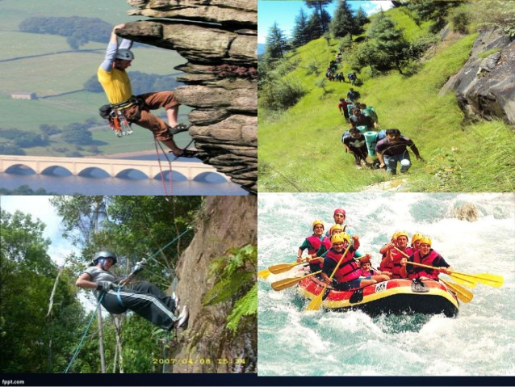

* Health Tourism

Medical tourism refers to people traveling to countries other than themselves to seek medical attention. In the past it was usually referred to those who traveled from less developed countries to major medical centers in highly developed countries for unavailable treatments at home. However, in recent years, it is equally referring to people from developed countries who go to developing countries for cheaper medical care. Motivation may also be for medical services not available or invalid in the home country.

The most frequent medical tourism is for surgery (cosmetics or otherwise) or similar treatments, although people also travel for dental tours or fertility tourism. Persons with rare condition can go to countries where treatment is more understood. However, almost all types of healthcare are available, including psychiatry, alternative remedies, recovery treatments, and even funeral services.

Medical travelers are subject to several risks, such as deep vein thrombosis from air travel or poor post-operative care.

Health tourism is a broader term for travel that focuses on medical treatment and the use of health care services. It encompasses a wide area of ​​health-oriented, tourism comprising preventive and conductive healthcare to the form of recovery and curative travel. Health tourism is a related field.

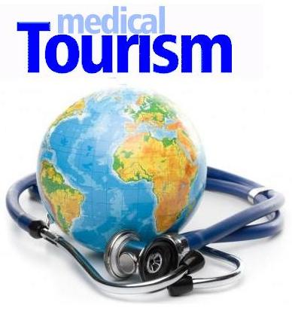

* Sports tourism

Sports tourism refers to travel which involves either observing or participating in a sporting event staying apart from their usual environment. Sport tourism is a fast-growing sector of the global travel industry. Sports tourism is traveling from one region, country, state, etc. to another in order to watch a sports competition or game. While sports tourism has not always been extremely popular, during the recent decade the amount of people attending out of area sporting events has drastically increased. People are now traveling far and wide just to attend their favorite events, and it is no wonder as to what has encouraged the sudden spike in popularity.

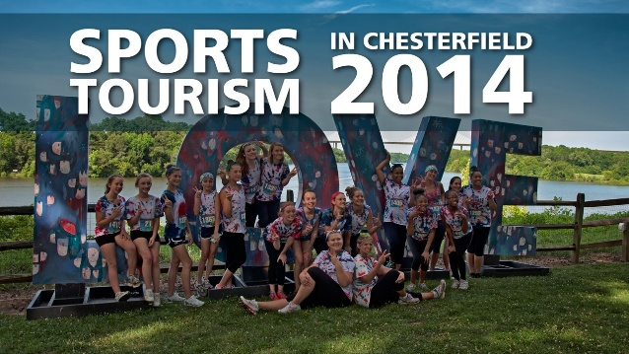

* Business Tourism

Business tourism or business travel is a more limited and focused subset of regular tourism. During business tourism (traveling), individuals are still working and being paid, but are doing so away from both their workplace and home. Some definitions of tourism tend to exclude business travel.

Tourism Define as a Travel is a short-term move while people go to destinations outside of where they usually live and work, and their activities while they are at the destination. Traveling is categorized as recreational tourism, cultural tourism, religious tourism, family tourism, health tourism, sports tourism, educational tourism, business tourism, and alternative forms of tourism.

**Q3:Describe the lodging accommodation and types of Hotel accommodation.**

Accommodation or holiday accommodation is a type of accommodation. People who travel and stay away from home for more than a day need sleep, rest, food, safety, protection from cold or rainy temperatures, luggage storage and access to the same household functions. There are many types of accommodation.

* Hotel

An establishment that provides travelers with accommodation and other guests. Depending on size, location and convenience, the hotel is generally rated from one star to five stars, but grading (from "A" to "F") and other scheme values ​​are also used to categorize hotels around the world.

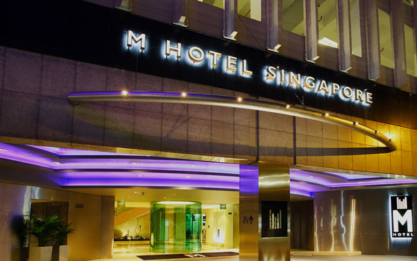

* Hostel

Ideal for travelers and backpacker's budget, hostels are cheap accommodation types, usually with shared bedrooms and common facilities.

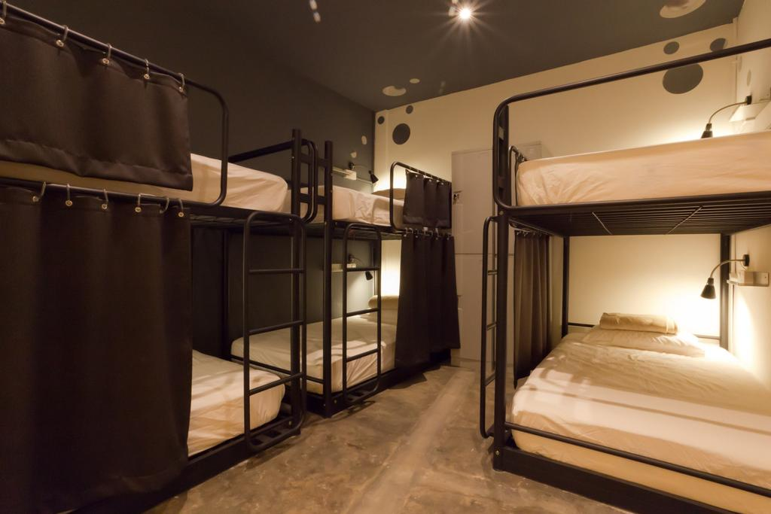

* Motel

Originally designed for drivers, the motel is a roadside hotel equipped with minimal amenities and ample parking for motor vehicles.

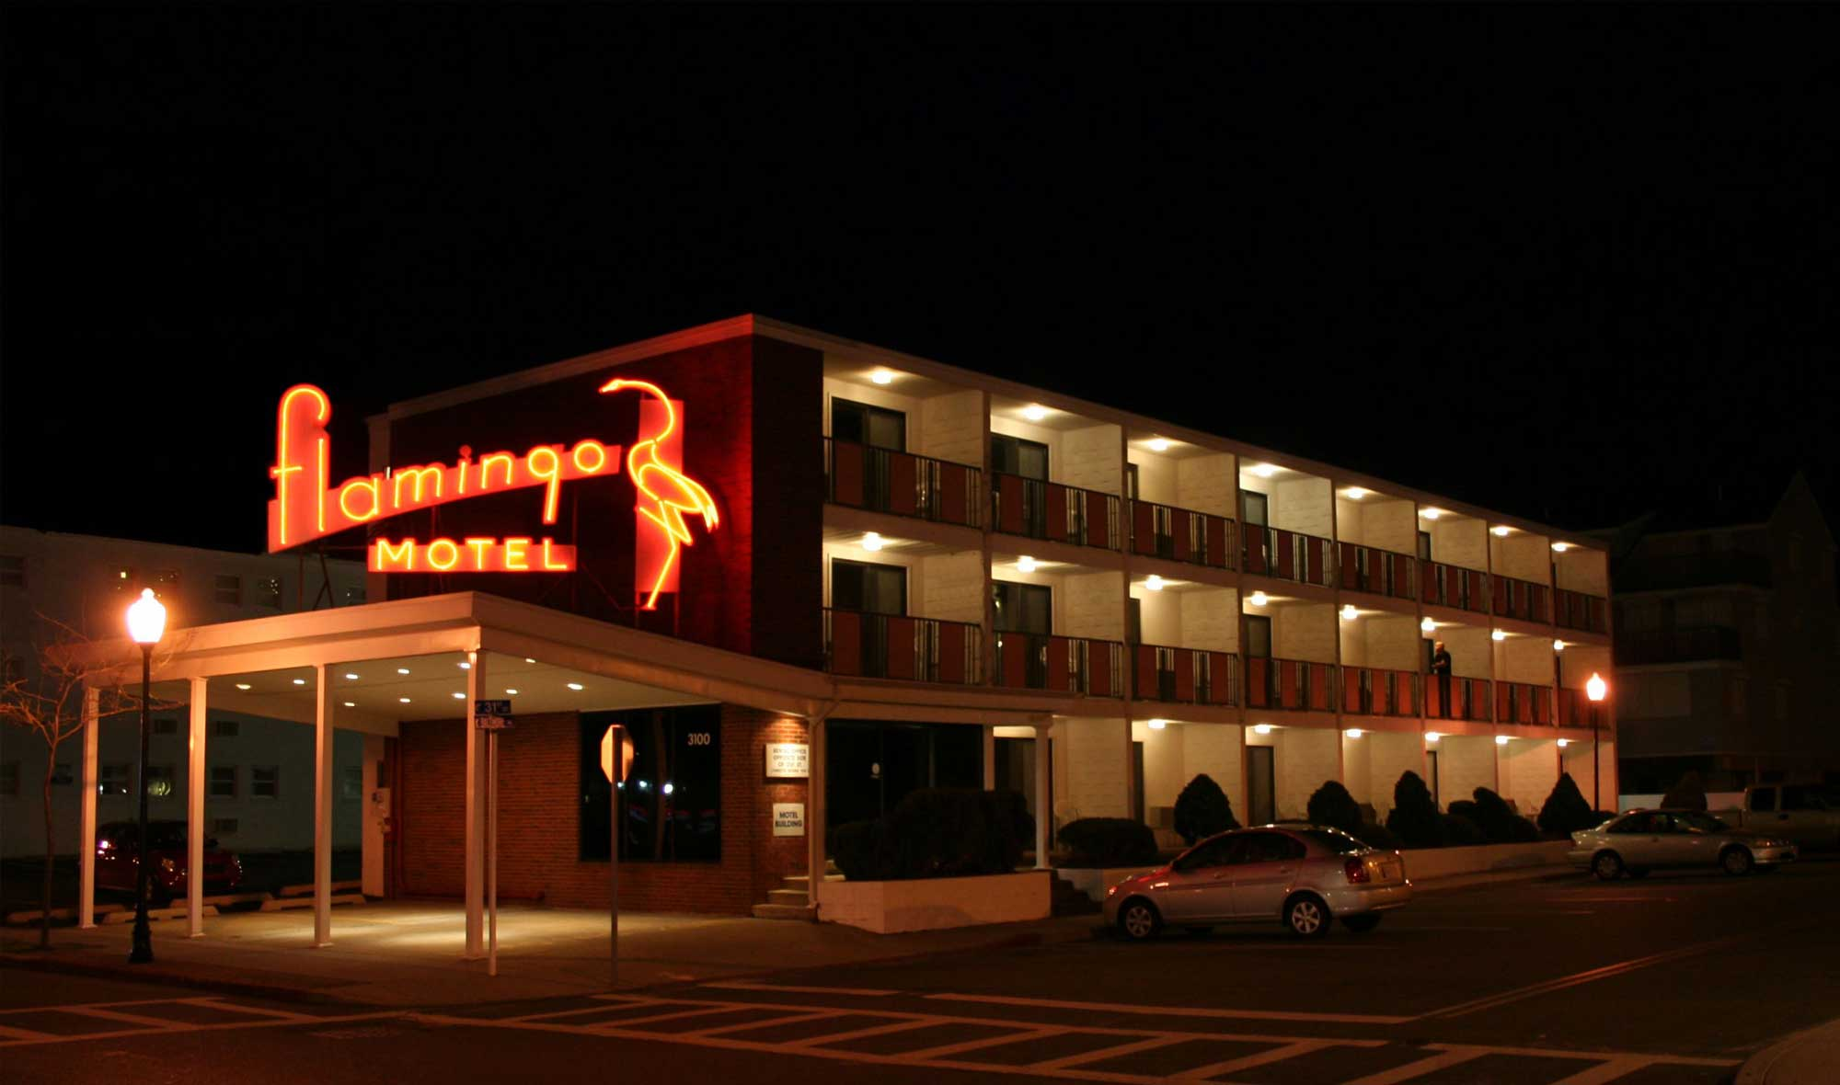

* Cottage

In the tourism sector today, the term cottage is used to describe small holiday homes, usually in rural areas. It may carry connotations as old or old buildings. In modern use, a hut is usually a modest, usual place of residence, usually in a rural or semi-rural location.

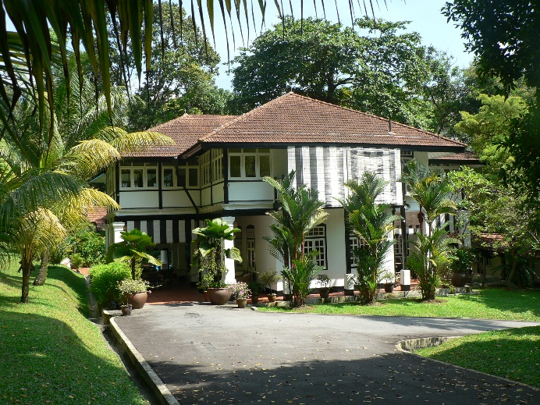

* Chalet

Chalet is a typical alpine-style wooden building inside and around the mountain resort.

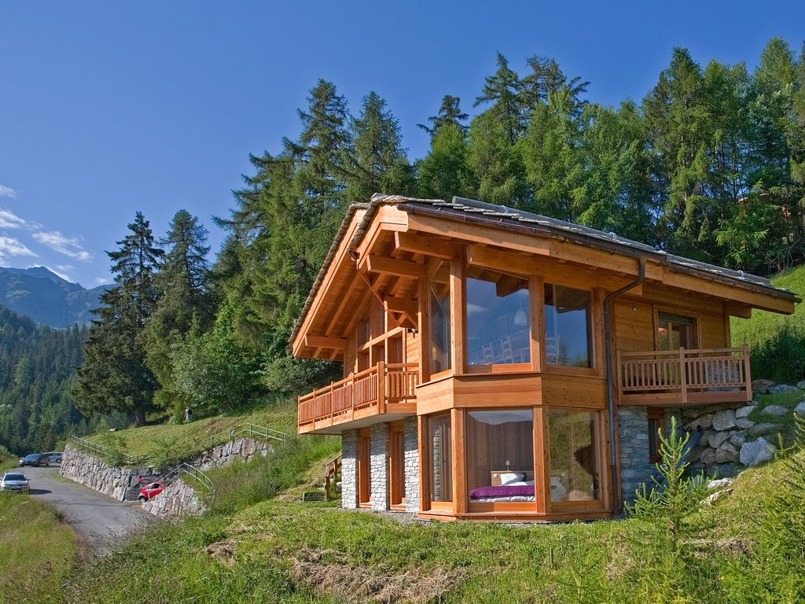

* Boutique Hotel

Comfortably furnished with themed style, individual, intimate boutique hotel in size and focus on providing guests with high quality and personal experience.

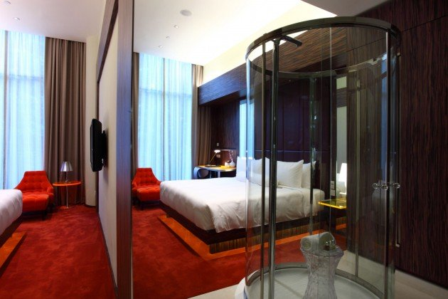

* Mansion

Typically built for luxury homes, large houses, luxury homes that generally pay homage to historic architectural styles.

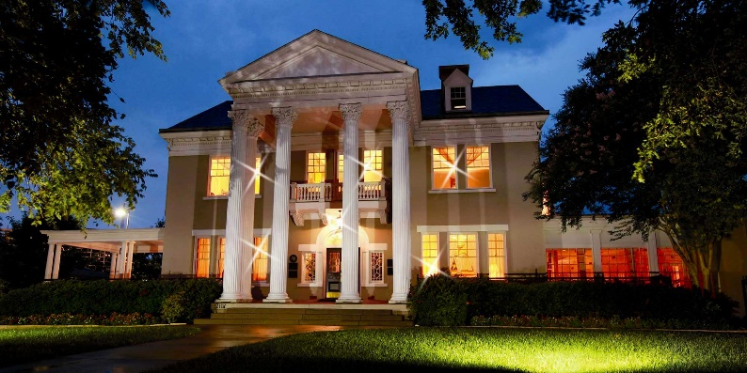

* Lodge

Although the word 'lodge' has many different meanings, one refers to a small rural home used by people who are on holiday or seasonally occupied by sports enthusiasts (ski huts, hunting huts).

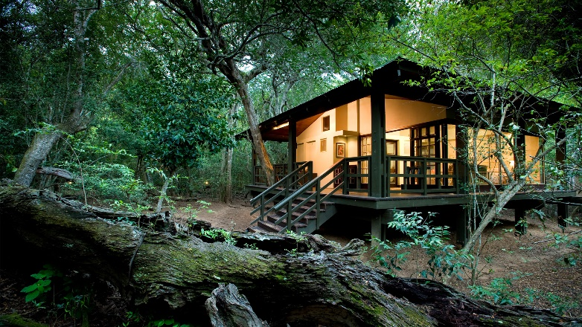

* Timeshare

Usually located on the destination you are looking for, timeshare is a kind of holiday property with ownership and common use rights. These features typically place condominiums, where multiple parties hold the right to use the property, and each of the same property owners is given their period of time. Minimum purchase is a one-week tenancy, and high season seats require a higher price. Units can be sold as partial ownership, lease, or "right to use", where no claims of ownership of the property. Ownership of the timeshare program varies, and has changed for decades to accommodate the changing needs of laypeople who prefer timeshare ownership to more conventional forms of accommodation such as resorts, hotels and motels.

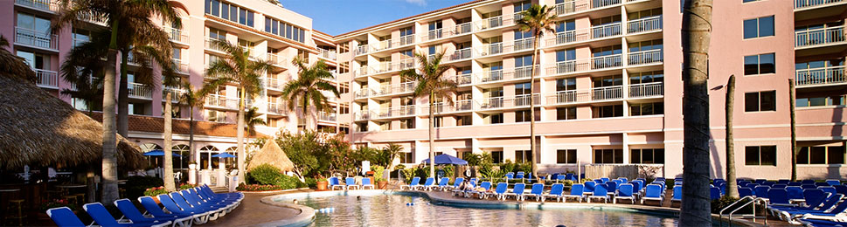

**Q4: Explain the Significant of Entertainment in this industry.**

Entertainment is any activity that provides diversion or allow people to entertain themselves in their free time, and can also provide fun, fun and laughter. People can make their own entertainment, as they spontaneously create games; participate actively in activities they can entertain, such as when they play sports as a hobby; or use passive entertainment products, such as when they attend the show, theme park, cruise and ETC

The entertainment industry not known as show business or biz show is part of the economic tertiary sector and includes a large number of sub-industries that are intended for entertainment. However, this term is often used in the mass media to describe the mass media of the company that handles the distribution and manufacture of entertainment mass media. In popular terms, the term biz specifically involves art exhibited commercially, especially musical theater, vaudeville, comedy, film, and music. It is used for every aspect of entertainment including cinema, television, radio, theater and music.

* Cruise

A cruise ship is a luxury boat used to carry passengers on a fun cruise on the journey which is part of the experience as a variety of destinations on the way. In contrast to seafarers transporting passengers from one point on the world to another that often passes through the oceans, cruises or cruise ships as it is most known, bringing people on board to various travel trips, from one day up to a week and peak in the original port. This is a very refreshing way for excitement and recreation, which relieves the mind and increases the energy.

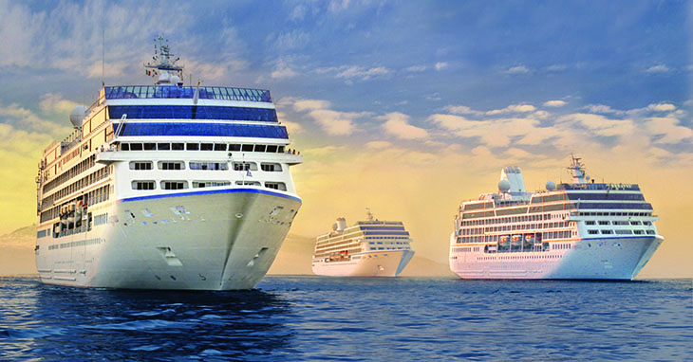

* Night Clubs

The nightclub (or club) is an entertainment venue and bar serving alcoholic beverages that usually operate late in the night. The nightclub is generally distinguished from a regular bar, pub or bar by inserting the stage for live music, one or more DJ's dance floor area and space, where a DJ plays record music and where colored lights illuminate the dance area. Another difference is that although many pubs and sports bars are meant for the mass market, nightclubs are usually aimed at the special market of music and dance fans and clubs. The luxurious nature of this nightclub can be seen in the VIP area admission at several nightclubs, for celebrities and their guests. Night clubs are far more likely than pubs or sports bars to use a bouncer to display a candidate club for entry. Some night club bouncers do not recognize people who have jeans or other unofficial clothing or gang out as part of the dress code. The busiest nights for the nightclub are Friday and Saturday nights. Most clubs or night clubs meet certain genres of music, such as home music or hip hop.

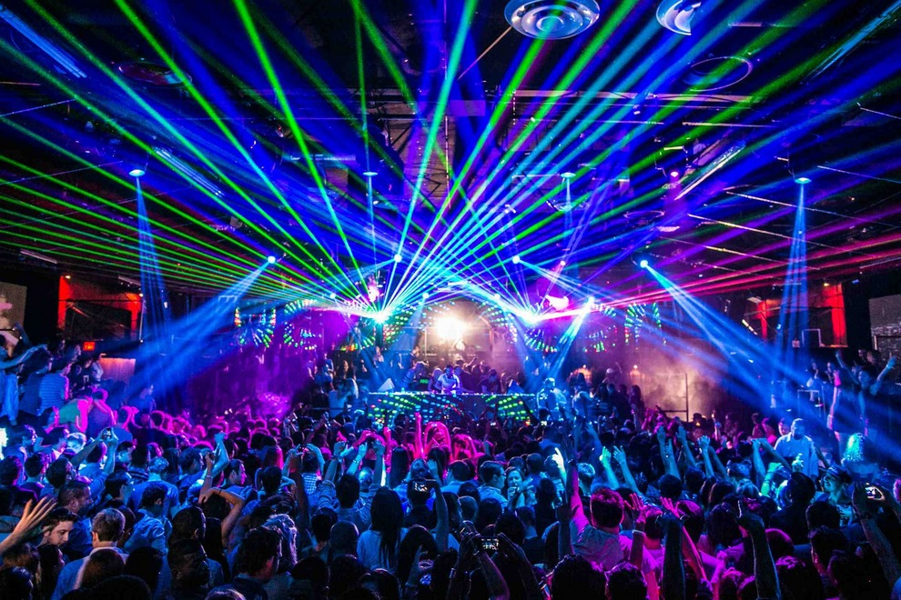

* Banquets

Banquets have been a place of entertainment since ancient times, persisting until the 21st century, when they are still used for many of their original destinations - to attract visitors, especially important ones; to show hospitality; as an opportunity to present entertainment such as music or dance, or both. In modern times, banquets are prepared commercially, for example, at the restaurant and combined with a dinner party. Cooking by a professional chef has also become a form of entertainment as part of a global competition.



* Sports

Sports competitions are always entertaining to the public. To distinguish players from the audience, the latter is often known as spectators. The developments in the stadium and the auditorium design, as well as in recording and broadcasting technology, have enabled off-the-spot viewers to watch sports, with the result that the size of the audience has grown larger and the sport of the audience has become increasingly popular. The two most popular sports with global appeal are football and cricket associations. Their main international competition, World Cup and test cricket, are broadcast around the world. Beyond the enormous numbers involved in playing this sport, they are renowned as the main source of entertainment for millions of non-worldwide players.

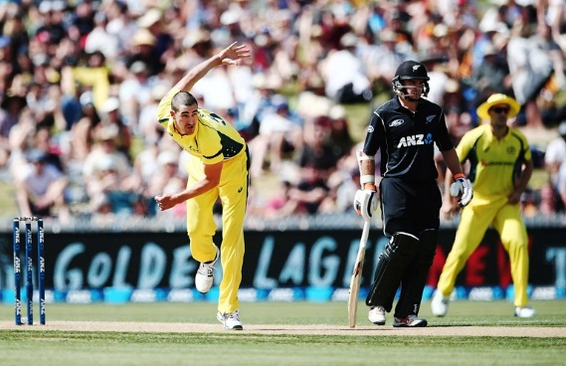

**Conclusion**

In conclusion, this is a tremendous economic contribution to the economy today. It's a good way for people to spend their money and for cities to attract others. By doing so, cities around the world attract millions of dollars just so that strangers get a chance to experience life in new places. I look forward to doing many trips because I believe it's a great way of life. Experiencing culture, religion, food, sports, entertainment shows, and public life in a new place is the best way to live in full. One day I hope I can open our own hotel chain and attract many visitors to new cities. From the above discussion it can be concluded that in business related services such as in cafes that require education and training cannot be ignored. A strong and loyal customer base that is satisfied and happy with the service, there is a need to provide timely and systematic training to staff members from front desk workers to salespeople o hotel workplaces. Executives are also required to be trained in different fronts to acquire some of the specialized skills required to succeed in a well-characterized hotel workplace with high rate of shifts and low job satisfaction among employees. Computers can be used as an efficient and inexpensive medium providing training to cafe workers. However, there is a need to install the appropriate equipment as planned by a training program designed to make the whole system able to compete with small service-oriented companies.

**References**

1. <https://www.slideshare.net/pascastpt/definition-of-tourism-69438879?qid=2c567f12-6a95-499e-b2f4-642627898e51&v=&b=&from_search=2>
2. <https://www.slideshare.net/heraesquivel/introduction-to-hospitality-industry-39956160?qid=c5ebaf22-9f59-4fde-93c5-b613dcbb45f5&v=&b=&from_search=15>
3. <https://www.slideshare.net/1stborn31/types-of-tourist?next_slideshow=1>
4. <https://www.slideshare.net/ALTINBAKU/the-different-types-of-tourism>
5. <https://www.slideshare.net/heraesquivel/introduction-to-hospitality-industry-39956160?qid=c5ebaf22-9f59-4fde-93c5-b613dcbb45f5&v=&b=&from_search=15>
6. <https://en.wikipedia.org/wiki/Hospitality_industry#Restaurants_and_bars>
7. <http://www.tourismsociety.org/page/88/tourism-definitions.htm>
8. <https://www.slideshare.net/SBrooker/tourism-ppt-7748923?next_slideshow=3>
9. <https://www.google.com.sg/search?q=%E2%80%A2+Explain+the+Significant+of+Entertainment+in+this+industry.&oq=%E2%80%A2+Explain+the+Significant+of+Entertainment+in+this+industry.&aqs=chrome..69i57.1374j0j1&sourceid=chrome&ie=UTF-8>
10. <https://www.google.com.sg/search?q=cruise&source=lnms&tbm=isch&sa=X&ved=0ahUKEwjQ55D0nZ3WAhVEuY8KHex9AP4Q_AUICigB&biw=1600&bih=770#imgrc=_>

**Appendix**

